**Primary Source:**

I started research on this system software from last one year and I learned and gather much data from internet, books. The process of face recognition is divided into two stages, training and recognition stages, shown in Figure

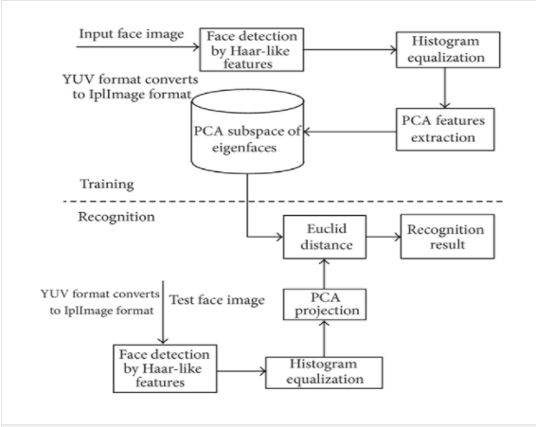

**Face Training**

To ensure convenient face image processing, the Haar-like face detection algorithm (Viola-Jones method) is used to identify face region. In order to enhance the contrast of image, reduce the influence from external factors and improve the following recognition rate; the face image identified is processed with the histogram equalization.

**Face Recognition**

Similarly, the test of face image is processed through format transformation, Haar-like face detection, and histogram equalization.

**Major Algorithms**

**Haar-Like Features**

This feature corresponds to black rectangle and the white rectangle. Each feature is composed of 23 rectangles, and they are applied in the detection of edge-feature, linear-feature, and center-feature. Value of each feature is made up by the sum of pixel values in corresponding rectangle region.

**Integral Image**

Integral image is a method of fast calculation of rectSUM(ri) with the idea of replacing time with space. The sum of pixel values in rectangle region formed from starting point of image to the rest is saved as an array. We can directly use the array to do calculation when we need to calculate rectSUM(ri) of certain region. This method avoids recalculation of pixels of this region; so, calculation speed improves.

**Adobos Algorithm**

ad boost algorithm is a kind of classifier algorithms. Its basic idea is constructing an accurate classifier with strong ability of classification by means of combining a large number of simple classifiers according to some rules.

**FEATURES:**

**●Face detection tracking**

Quickly and accurately detect the face and track location of each face in still image or video streaming

**●Accurate Localization of Facial Feature Points**

Accurately locate the key feature points on the face in the picture (5 key points such as eyes, nose, mouth, etc.), used to determine the face posture and face alignment

●**Face image quality assessment**

A quality threshold can be used during face enrollment to ensure that only the qualified face template will be stored into database to decrease the effect of image quality on matching performance.

●**Live face detection**

A conventional face identification system can be tricked by placing a photo in front of the camera.

We are able to prevent frauds with using photograph or 3D printed mask with SDK as follows,

1) active mode with face images captured in visible light: SDK requires user actively assist to perform particular actions such as open mouth, head movements to judge it's a 'live' human or not.

2) Near-infrared version: using imaging features of Near-infrared to achieve high robustness of live face detection.

●**Face identification capability**

It can be used for fast matching in 1:1 mode (verification), as well as 1: N (n= large database size) mode (identification).  Verify if it's same person by calculates two faces’ similarity based on features extraction. If the matching score is higher than the pre-defined facial matching threshold then the input template is said to have successfully matched with the stored template.

**Secondary Source:**

As a secondary source for face recognition system, I note down previous researches, theories, laws and principles. As there has been a rapid development of the reliable face recognition algorithms in the last decade. The traditional face recognition algorithms can be categorized into two categories

* holistic features
* local feature approaches.

However, from the last decades many new researchers work on it due to large variations in illumination conditions, facial expression and other factors, these methods may fail to adequately represent the faces. The main reason is that the face patterns lie on a complex nonlinear and non‐convex manifold in the high‐dimensional space.

In order to deal with such cases, nonlinear extensions have been proposed like kernel PCA and kernel LDA.

**Artificial Neural Networks in face recognition**

In artificial neural networks are used to solve nonlinear problem. To recognize human faces, a non‐convergent chaotic neural network.

It is integrated with a non‐negative matrix factorization to recognize faces. Moreover, for face and speech verifications they utilize a momentum back propagation neural network. distance metrics and normalized cross‐correlation for face recognition is applied.

**Gabor wavelet‐based solutions**

These Solutions helps me in bringing widely used face recognition representations and its features are recognized better in term of recognition rate. Moreover, it is demonstrated to be discriminative and robust to illumination and expression variations.

**Face descriptor‐based methods**

Local feature‐based face image description provides a global description. So local features of the image are evaluated in the neighboring pixels and then aggregated to form the final global description. This is unlike global methods in which the entire image is utilized to produce each feature, where the first steps start with the description of the face realized at a pixel level by making use of the local neighborhood of each pixel. Then, the image is divided into a number of subregions, and from each subregion, a local description is formed as a histogram of the pixel level descriptions calculated in the previous step. Next, the information of the regions is combined into the final descriptor by concatenating the partial histograms.